**AudioDAC Module Description Document**

**1.Introduction**

The Audio DAC module consists of two parts: a dual-channel digital-to-analog converter (DAC) and an analog MIXER output. The digital-to-analog converter (DAC) is mainly used to convert digital signals into analog signals and output them to the subsequent analog circuits. The analog output section is mainly used to perform gain control and mixing processing on the processed analog signals and finally output them to the pins. There are two options for the data source of the digital-to-analog converter (DAC) : one is from the PMEM, and the other is from the I2S module.

In addition, the clock source of the Audio DAC module is the same as that of the Audio ADC and I2S. One can be generated by an internal generator, and the other is injected through an external GPIO. For details, please refer to the Audio ADC section.

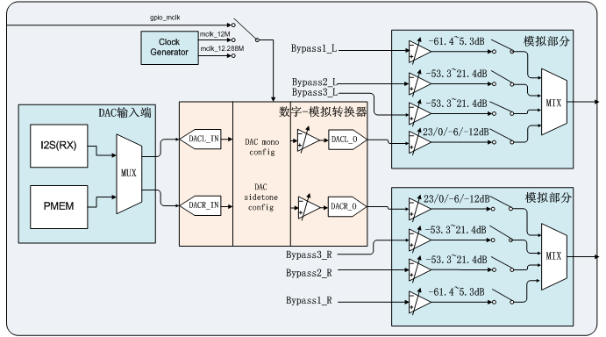

Figure 1 Audio DAC Overall Block Diagram

Translation:

模拟部分=Analog Section

DAC输入端=DAC Input Terminal

数字-模拟转换器 = Digital -to-Analog Converter (ADC)

模拟部分=Analog Section

**2.Main Features**

* Supports 9 sampling rates: 8kHz, 11.025kHz, 12kHz, 16kHz, 22.05kHz, 24kHz, 32kHz, 44.1kHz, 48kHz;
* Each channel in the analog section supports independent volume control.
* The digital-to-analog converter section supports digital volume control.
* The output supports both mono and stereo types.
* Support Sidetone function;
* Support soft mute and hard mute;
* Supports direct drive headphones;
* Two sampling rate frequency division modes are supported: one is the frequency division ratio of an integer multiple of the sampling rate, and the other is the frequency division ratio of a non-integer multiple of the sampling rate.
* Support fine-tuning of the sampling rate;

1. **Function Description**

**3.1. Clock Mode**

The Audio DAC, Audio ADC and I2S share a single master clock source. Its source supports two types: one can be generated by an internal generator, and the other is injected into an external clock through GPIO. As shown in the following figure.

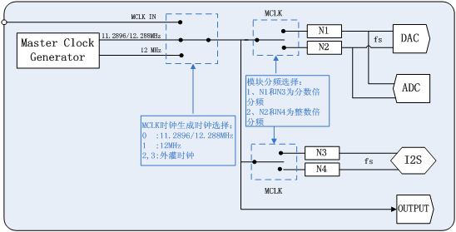

Figure 2 Audio Module Clock Block Diagram

Translation:

MCLK时钟生成时钟选择：= MCLK clock generation clock selection:

0 :11.2896/12.288MHz

1 :12MHz

2,3:外灌时钟= 2, 3: External injection clock

Translation:

模块分频选择：= Module frequency division selection:

I. NI和N3为分数倍= I. NI and N3 are fractional multiples

分频=Frequency division

2、N2和N4为整数倍=2. N2 and N4 are integer multiples

分频=Frequency division

**3.1.1. Audio Clock Relationship**

As shown in the following figure, the Audio DAC clock can come from the internal generator or from the external injection clock. Among them, the internal generator can output two different types of clocks, namely the NORMAL MODE and USB MODE usually defined in the SDK. The main clock of NORMAL MODE is an integer multiple of the sampling rate, that is, MCLK = N \* fs, where fs is the sampling rate and N is a positive integer. The USB MODE is not affected by the sampling rate and has a fixed output of 12MHz.

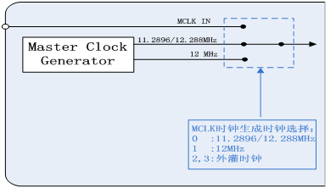

Figure 3 MCLK Clock Block Diagram

Translation:

MCLK时钟生成时钟选择：= MCLK clock generation clock selection:

0 :11.2896/12.288MHz

1 :12MHz

2,3:外灌时钟= 2, 3: External injection clock

The functions involved in the selection of the master clock source in the Audio DAC module are shown in the following table:

Table 1 Functions related to the master clock of the Audio DAC module

|  |  |
| --- | --- |
| Function name | Description |
| DacAdcSampleRateSet | The Mode parameter in the function interface is the selection of the main clock source: 12MHz, 11.2896/12.288MHz or an external clock |
| Adc8KDac48KSampleRateSet |
| Adc48KDac8KSampleRateSet |

**3.1.2. Sampling Rate and Master Clock**

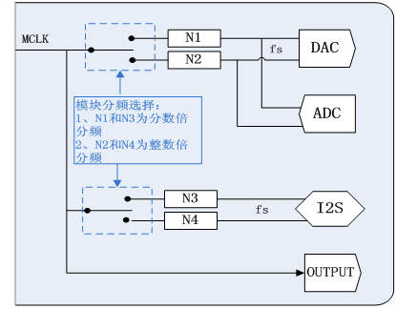

Figure 4 Relationship Between Master Clock and fs

Translation:

模块分频选择：= Module frequency division selection:

I. NI和N3为分数倍= I. NI and N3 are fractional multiples

分频=Frequency division

2、N2和N4为整数倍=2. N2 and N4 are integer multiples

分频=Frequency division

As shown in Figure 4, the sampling division ratio of the Audio DAC supports two types, namely N1 and N2. Among them, N1 is the fractional multiple relationship of the sampling rate and is applicable to the 12MHz master clock. N2 is an integer multiple of the sampling rate and is applicable to 11.2896/12.288MHz. Therefore, the crossover ratio of the sampling rate of the Audio DAC must be consistent with the type of the master clock; otherwise, the obtained sampling rate will be different from the theoretical value.

Table 2 Functions related to frequency division Ratio in Audio DAC

|  |  |
| --- | --- |
| Function name | Description |
| DacConfig | The ClkMode in the function interface refers to the selection of the frequency division ratio of the Audio DAC sampling rate |
| AdcDacClkModeSet |
| DacIsUsbMode |

**3.1.3. Fine-tuning Mechanism**

Audio DAC supports two mechanisms: hardware fine-tuning and software fine-tuning. The hardware fine-tuning mechanism is only applicable to USB MODE. The software fine-tuning mechanism is applicable in both clock modes, but it is recommended to use the hardware fine-tuning mechanism in USB MODE.

Table 3 Scope of Application of Fine-tuning Mechanism

|  |  |  |
| --- | --- | --- |
| Fine-tuning mechanism | USB MODE | NORMAL MODE |
| Hardware fine-tuning mechanism | √ | × |
| Software fine-tuning mechanism | √ | √ |

**3.2. Digital-to-Analog Converter (DAC)**

A digital-to-analog converter (DAC) is a dual-channel sigma-delta DACs with a high signal-to-noise ratio, used to convert digital signals into analog signals and then send them to subsequent analog circuits. The digital-to-analog converter (DAC) supports digital volume control, mute processing, and output mode selection functions.

**3.2.1. Input Terminal**

There are two options for the data input end of the digital-to-analog converter (DAC), which can come from the PMEM memory or from the I2S module.

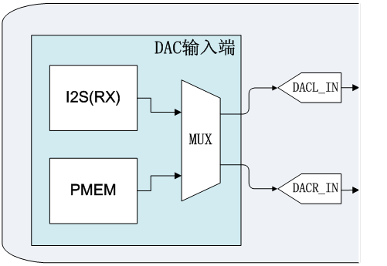

Figure 5 DAC Input Terminal Block Diagram

Translation:

DAC输入端=DAC Input Terminal

Table 4 DAC Input Source Related Functions

|  |  |
| --- | --- |
| Function name | Description |
| DacConfig | Digital-to-analog converter volume control |

**3.2.2. Volume Control**

The left and right channels of the digital-to-analog converter (DAC) can independently control the volume, with a control range of 0dB to -72dB for both. The calculation formula is as follows: when x = 0xfff, the volume of y decreases by 0dB. When x = 1, the volume of y decays by approximately -72dB.

IMG_256 (Formula 1)

Table 5 Functions Related to Digital-to-Analog Converter Volume Control

|  |  |
| --- | --- |
| Function name | Description |
| DacVolumeSet | Digital-to-analog converter volume control |

**3.2.3. Mute Control**

The digital-to-analog converter (DAC) supports two types: softe mute and hard mute, as shown in the following figure.

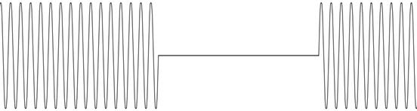

Figure 6 Soft Mute Type

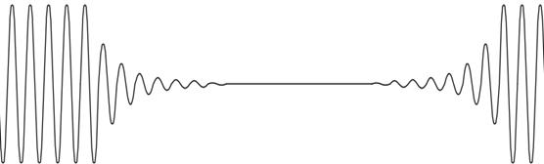

Figure 7 Hard Mute Type

The relevant functions are shown in the following table:

Table 6 Control functions related to two types of mute

|  |  |
| --- | --- |
| Function name | Description |
| DacSoftMuteSet | Soft mute control |
| DacDigitalMuteSet | Hard mute control |

**3.3. Analog Output Terminal**

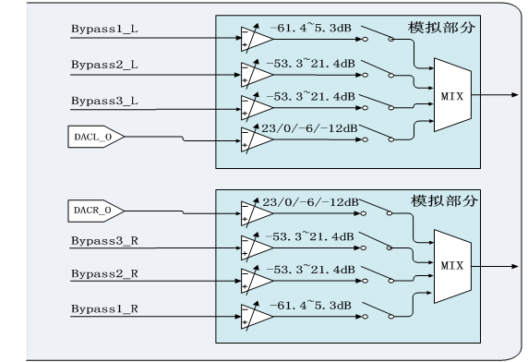

Figure 8 Audio DAC Analog Output Terminal

Translation:

模拟部分=Analog Section

模拟部分=Analog Section

The analog output terminal of the Audio DAC has four selectable input audio sources: Bypass1, Bypass2, Bypass3, and digital-to-analog converter. Each channel supports independent volume control. Among them, Bypass1 is the analog signal directly from the LINE IN end, with a volume adjustment range of -61.4 to 5.3dB. Bypass2 is the analog signal directly from the FM end, with a volume adjustment range: The volume adjustment range is -53.3dB to 21.4dB. Bypass3 is the analog signal directly passed from the PGA end. The volume adjustment range is -53.3dB to 21.4dB. There are four options for the mode channel volume at the digital-to-analog converter end: 23dB, 0dB, -6dB, and -12dB.

Table 7 Functions related to the analog output terminal

|  |  |
| --- | --- |
| Function name | Description |
| CodecDacInit | Initialize the Audio DAC and the energy ban Audio DAC |
| CodecDacDeinit |
| CodecDacChannelSel | For the input source selection of the analog output section, the second function will not perform the unmute operation when the configuration is completed. |
| CodecDacChannelSelNotChangeMode |
| CodecDacLineInGainConfig | The volume adjustment function of the four input sources in the analog output section |
| CodecDacFmInGainConfig |
| CodecDacMicInGainConfig |
| CodecDacAnaVolSet |

**4 Configuration Process**

Start

Power-on initialization

of the Audio DAC

Sampling rate configuration

Digital-to-analog converter configuration

Analog section input channel volume setting

Analog section input channel selection

Digital-to-Analog Converter Volume Configuration

End

Figure 9 Audio DAC configuration process